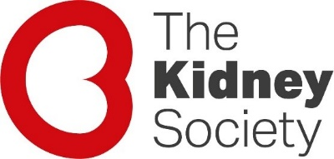

Nora Van der Schrieck Professional Development Scholarship
Application Form

Name / Position / Employer / Qualifications:

Describe the Professional Development Opportunity:

How will this contribute to your professional practice?

Please provide details of the costs involved e.g. conference registration fees, travel/accommodation costs etc.

- Please provide a letter in support of your application from your manager, supervisor or similar.
- Note the Nora Van der Schrieck Professional Development scholarships are only available to individuals working in the Northland, Auckland, Waitemata, Counties Manukau, Waikato, Bay of Plenty, Lakes, Hawkes Bay and Tairawhiti DHB catchment areas.
- Applicants will be notified by 31 July 2022

